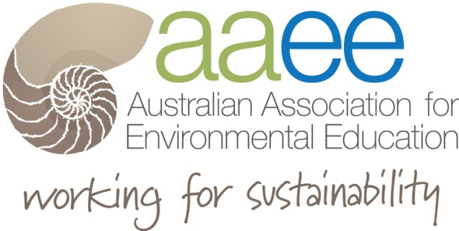

Brian Foreman Scholarship
Application 2021

Brian Foreman
For over 16 years Brian Foreman was an inspirational, practical and very down to earth leader in AAEE and environmental education circles. AAEE with the generous support of Brian Foreman's family renamed and extended the Travelling Scholarship to remember his contributions and recognise the work of others in the EE field.

Scholarship Information

A proposed budget of up to $700, which includes participation at the 2021 AAEE National Conference in Mandurah, Western Australia.

Applicants should submit one page submission that includes:
- Name and current role and contact details
- You are a current member AAEE
- How AAEE will benefit from the experience
- Why this professional development opportunity will beneficial your EE career

Post Conference report to be used in AAEE publications.

How the experience has enhanced my current work and ideas, skills and strategies that I learnt through the conference experience

Please submit your application to A/Prof Hilary Whitehouse via admin@aaee.org.au by 25th June.

The decision will be made by the AAEE Recognition Team to an AAEE member who can uphold Brian Foreman’s legacy to environmental education in Australia. Brian always found ways to support those in need of inspiration through his hands-on approach to environmental education, an infectious enthusiasm, a capacity to inspire and lead and an ability to work with all of the community.

For more information visit the AAEE website Awards - AAEE

